**IT Technician Skills Bootcamps**

**MY SQL ASSIGNEMENT**

**BY**

**MANUEL MUNTU**

**SUPERVISED BY VINITA SILAPARASETTI**

**MAY 2023**

MY SQL ASSIGNEMENT

Contents

**IT Technician Skills Bootcamps** 1

QUERY 1 2

*A)* Use store by bringing everything from customers 3

*B)* Finding the customer who ID=1, order by the first name 3

QUERY 2 3

Finding out customers’ last name, first name, their points and their points+10: 4

TASK 1 4

*Using the query 2 created changing the points to read times by 10 and plus 100. Recording the results in word document:* 4

TASK 2 5

*Writing a SQL query to return all the products in database in the result set. To show three columns, name, unit price, and new column called new price which is based on the expression (unit price * 1.1).* 5

*So, what to do is increasing the product price of each by 10%. So, with the query it is wanted that all the products be in original price, and the new price.* 5

TASK 3 6

*Creating a new query to find all the customers with a birth date >”1990-01-01”:* 6

EER Diagram ……………………………………………………………………………………………………………………..………………7

# QUERY 1

# Use store by bringing everything from customers*:*

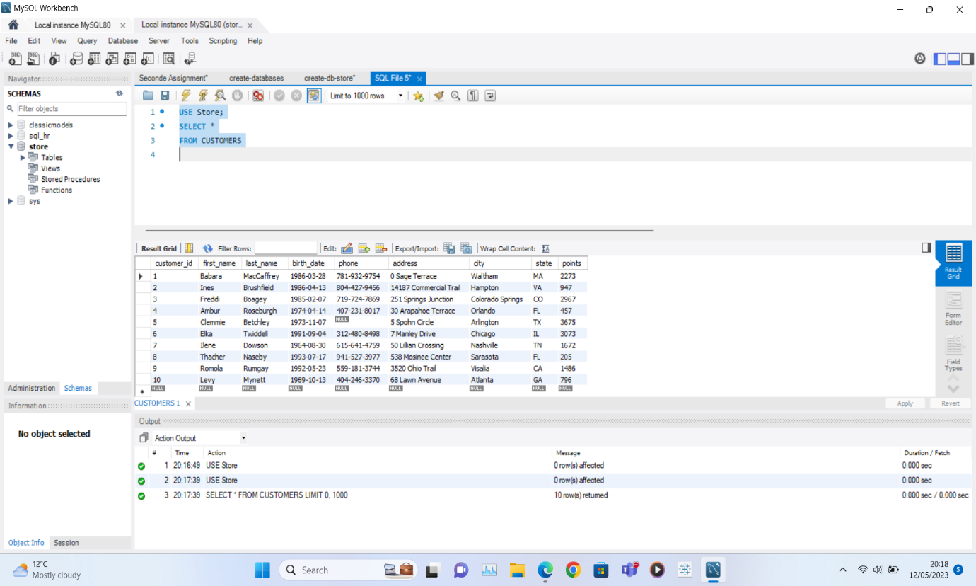

# Finding the customer who ID=1, order by the first name*:*

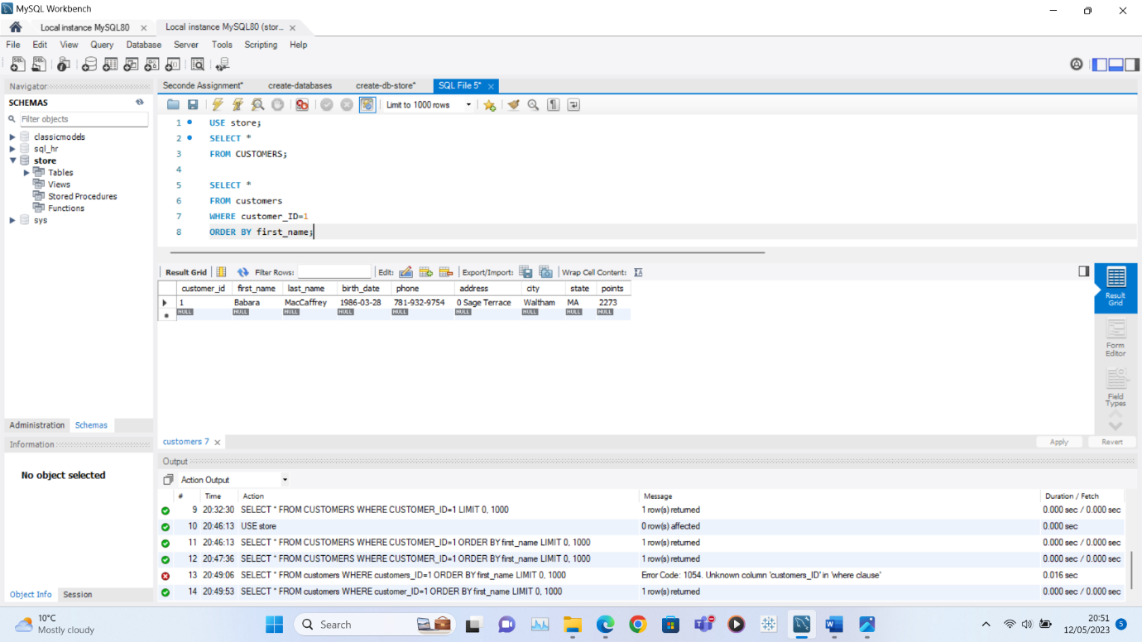

# QUERY 2

# Finding out customers’ last name, first name, their points and their points+10:

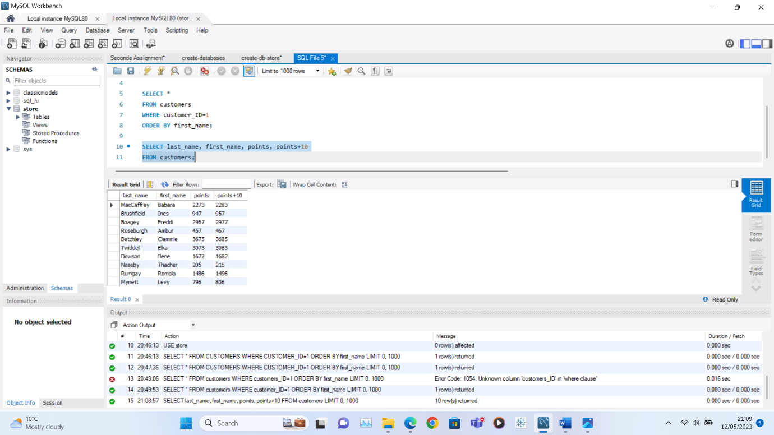

# TASK 1

# Using the query 2 created changing the points to read times by 10 and plus 100. Recording the results in word document:

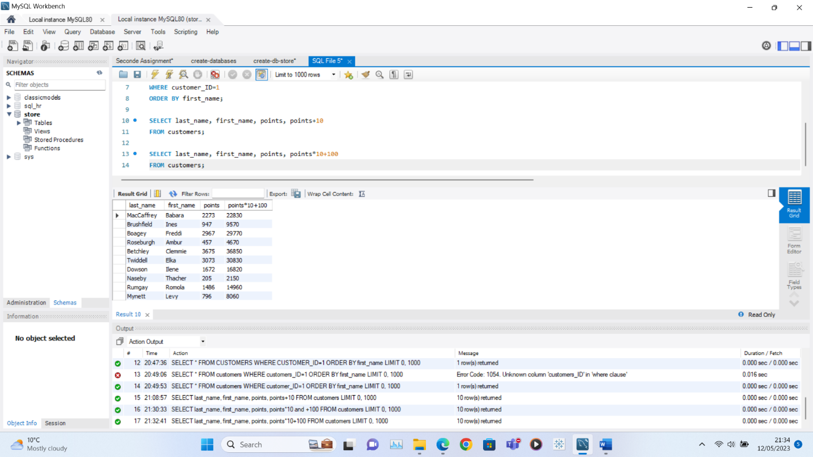

# TASK 2

# *Writing a SQL query to return all the products in database in the result set. To show three columns, name, unit price, and new column called new price which is based on the expression (unit price * 1.1).*

# *So, what to do is increasing the product price of each by 10%. So, with the query it is wanted that all the products be in original price, and the new price.*

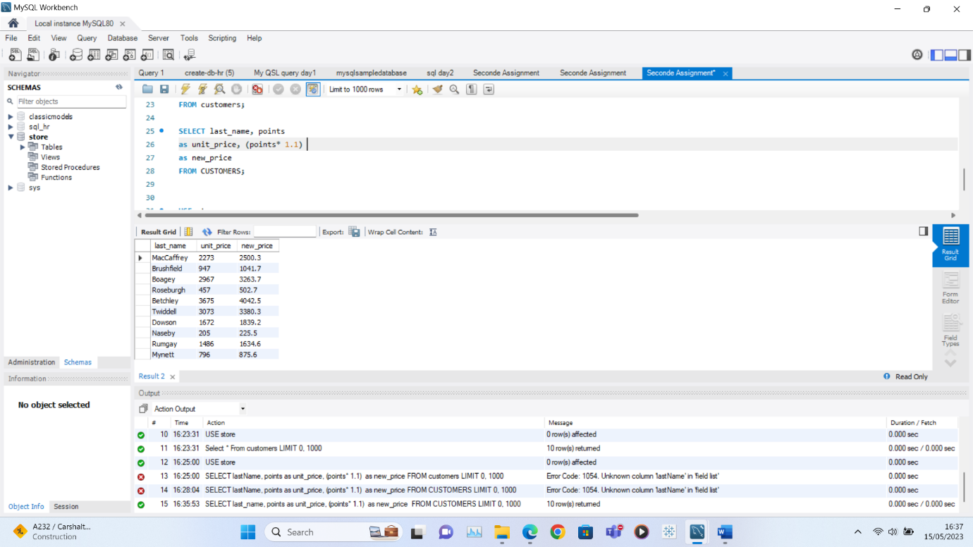

# TASK 3

# *Creating a new query to find all the customers with a birth date >”1990-01-01”:*

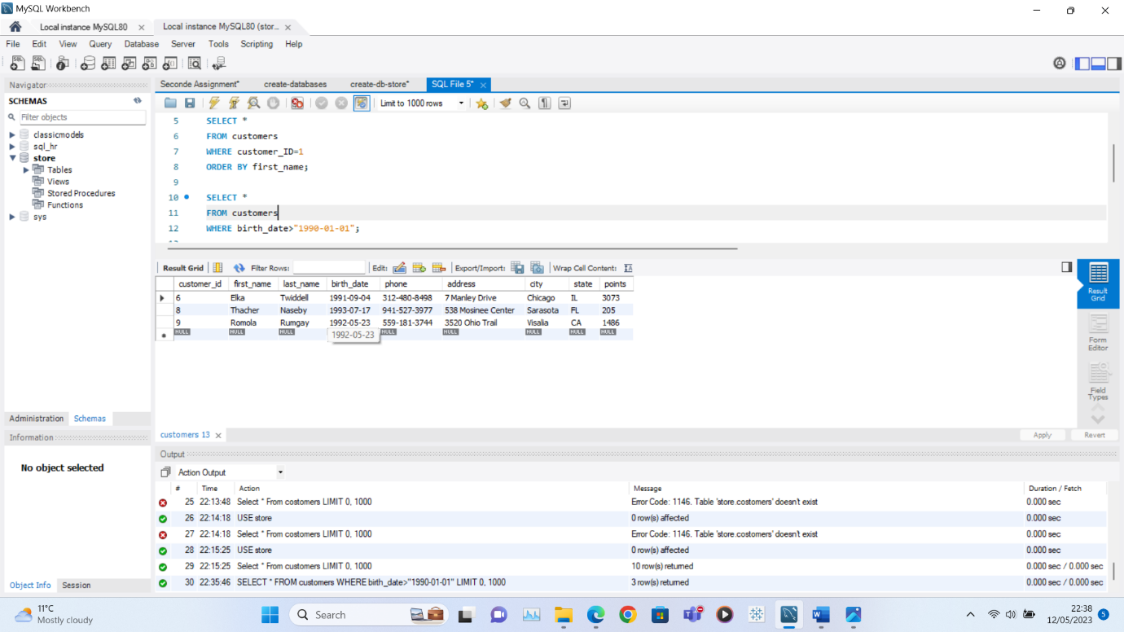

## EER DIAGRAM

